AFM training quiz
This is a take-home quiz, refer to your common sense, the Asylum MFP3D manual, the AFM tip specifications, your own notes, Youtube videos etc. Helpful videos include:
https://www.youtube.com/watch?v=8gCf1sEn0UU (Laser beam deflection technique used to monitor cantilever deflection and measure the amplitude signal).
https://www.youtube.com/watch?v=K9FgPWK3Co4 (Animation of ac mode imaging (= non-contact mode). Attractive force and repulsive force imaging. Feedback control).

_________________________________ took this quiz on _____________________________.
(your name) (today’s date)

I figured out the answers on my own (from scratch and/or looking at other resources).

__________________________________________
(signature)

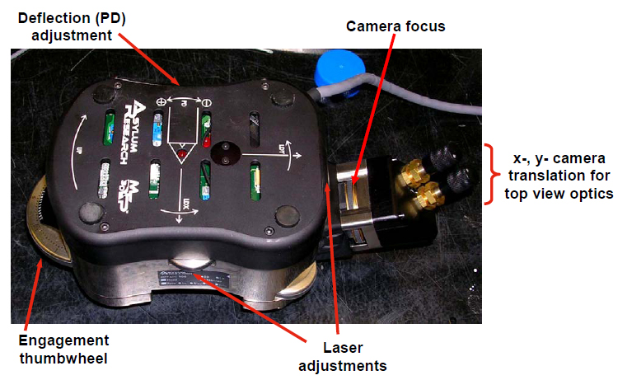
1. The figure above shows the AFM head which sits on three legs. Circle any of the following which can lead to a tip crashing into the sample:
a) Change to a thicker sample without adjusting leg length.
b) Change to a thinner sample without adjusting leg length.
c) Legs are set too short when placing the AFM head on the x-y stage
d) Legs are set too long when placing the AFM head on the x-y stage
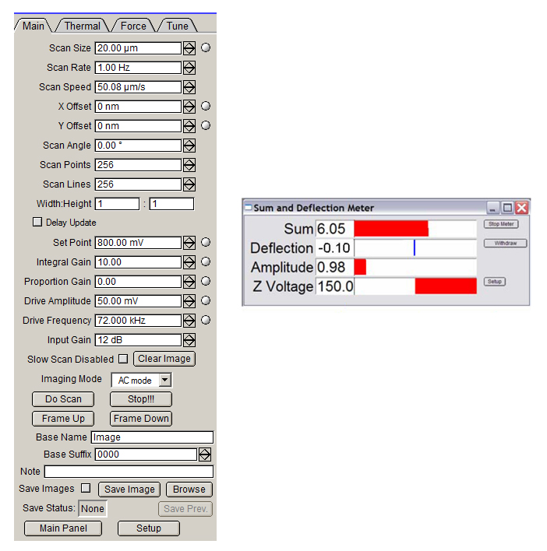
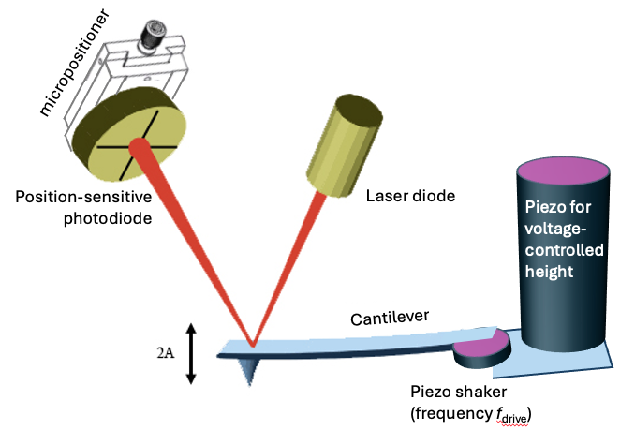
The left screenshot shows imaging parameters which the user can specify. The top right screenshot shows three measured signals and one feedback-controlled voltage. The user should be monitoring these four values. Question 2 is designed to check your physical reasoning and intuition about these imaging parameters, measured signals, and the feedback circuit. Be ready to explain your answer.
2. True/False, circle one choice for each statement below
T F When the “Sum” signal is 6.05, the “Amplitude” signal could be zero.
T F When the “Sum” signal is zero, the “Amplitude” signal will always be zero.
T F The “Amplitude” signal is measured using the position-sensitive photodetector. “Amplitude” corresponds to cantilever motion at a specific frequency (f_{drive}).
T F The “Deflection” signal is also measured using the position-sensitive photodetector. “Deflection” corresponds to the average position of the cantilever (fast oscillation in position are filtered out).
T F When the “Z Voltage” changes from 0 to 150 V, the tip moves several microns down, toward the surface.
T F If the user-defined parameter called “Drive Amplitude” is set to 50 mV, the measured “Amplitude” signal will be 0.05 V.
T F The user-defined parameter called “Set Point” should be higher than the measured “Amplitude” before we click “engage” (i.e. before we enable the feedback circuit).

3. The typical resonant frequency that we use to shake a cantilever is
a) 1 Hz
b) 500 Hz
c) 100 kHz

4. The typical frequency that we scan back and forth in the x direction is
a) 1 Hz
b) 500 Hz
c) 100 kHz

5. When you’re about to start the standard procedure for engaging the surface, what is the value of “Amplitude” signal?
a) 0.1 V
b) 1 V
c) 10 V

6. When using the standard procedure for engaging the surface, the value for 2A (see Figure) is approximately
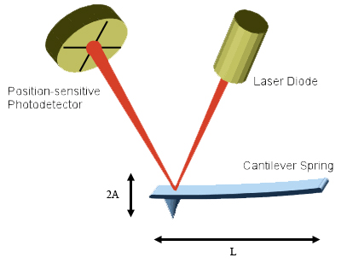
a) 1 nm
b) 10 nm
c) 100 nm
d) 1 μm
e) 10 μm

7. For the cantilevers used in our lab, L is approximately
a) 2 nm
b) 20 nm
c) 200 nm
d) 1 μm
e) 10 μm
f) 100 μm

