AFM training quiz
(this is a take home quiz, refer to your common sense, the AFM manual and your own notes):

_________________________________ took this quiz on _____________________________.
(your name) (today’s date)

without any help (figured things out from scratch, or found the answers independently).

__________________________________________
(signature)

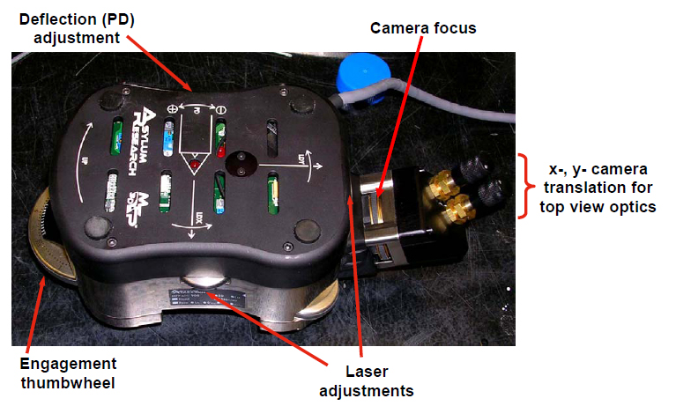
1. The figure above shows the AFM head which sits on three legs. Circle any of the following which can lead to a tip crashing into the sample:
a) Change to a thicker sample without adjusting leg length.
b) Change to a thinner sample without adjusting leg length.
c) Legs are set too short.
d) Legs are set too long.

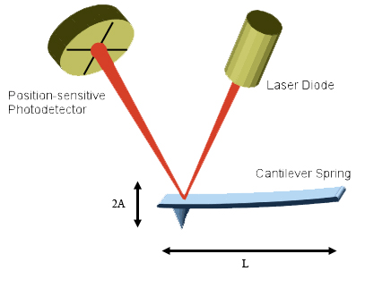
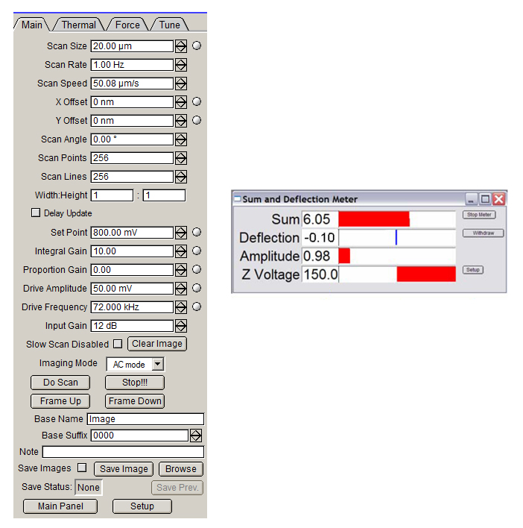
The images above shows the AC mode parameters, and signals, and a schematic of the AFM system. The AFM user must be very familiar with the parameters and signals and what they physically represent.

2. True/False, circle one choice for each statement below
T F When the “Sum” signal is 6.05, the “Amplitude” signal could be zero.
T F When the “Sum” signal is zero, the “Amplitude” signal will always be zero.
T F The “Amplitude” signal is measured by looking at the f_{drive}-frequency component of the signal from the position-senstive photodetector (f_{drive} is the frequency that we shake the base of the cantilever).
T F The “Deflection” signal is measured by filtering out fast oscillations from the photodiode output, leaving only the low-frequency component of the photodiode output .
T F When the “Z Voltage” changes from 0 to 150 V, the tip moves several microns down, toward the surface.
T F If the “Drive Amplitude” parameter is 50 mV, the “Amplitude” signal will also be 50 mV (0.05 V).
T F The “Set Point” parameter should always be higher than the free air amplitude (free air amplitude is the value of the “Amplitude” signal before engaging with the surface).
3. The typical frequency that the cantilever oscillates, f_{cantilever}, is
a) 1 Hz
b) 500 Hz
c) 100 kHz

4. The typical frequency that we scan back and forth in the x direction is
a) 1 Hz
b) 500 Hz
c) 100 kHz

5. When using the standard procedure for engaging the surface, what should the “Amplitude” signal read?
a) 0.1 V
b) 1 V
c) 10 V

6. When using the standard procedure for engaging the surface, the value for A (see Figure) is approximately
a) 1 nm
b) 10 nm
c) 100 nm
d) 1 μm
e) 10 μm

7. For the cantilevers used in our lab, L is approximately
a) 2 nm
b) 20 nm
c) 200 nm
d) 1 μm
e) 10 μm
f) 100 μm

